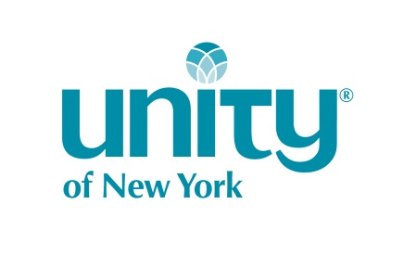DIVINE DANCER REGISTRATION FORM 2018
NAME:_______________________________________________________________________
CONTACT INFO:
Email:___________________________________Phone:_____________________
Address:___________________________________________________________
AVAILABILITY:
[ ] I am available to rehearse and perform for special events at Unity of New York
BACKGROUND:
Please give us a little information about your dance experience.
__________________________________________________________________________________________________________________________________________________________________________________________________________________________________________________________________________________________________________________________________________________________________________________________________________________________________________________________________________________________________________________________________________________________________________________________________________________________________________________________________________________________________________________________________________________________________________________________________________________________________________________________________________________________________________________________________________________________________________

Thank you for your willingness to share your time & talent with your spiritual home, Unity of New York. We will contact you soon with more information on the UNY DANCE MINISTRY.

